February 2023

**Statistical Analysis of Changes in Cultural Participation in Italy Between 2019 and 2020: The Impact of COVID-19**

**Abstract**

The purpose of the analysis is to observe how the tendency to participate in entertainment activities outside the home varies according to its type, geographical area, age, gender, and education level. Through the analysis of the attendance at each activity at the territorial level, it is discovered that the inhabitants of the centre-north are more active from the cultural activity point of view. This phenomenon is probably due to the geographical distribution of the offer of cultural services. Until now, the analysis covered each type of service, but to analyse the relationship between age, gender, educational level, and the type of entertainment activity, we focused on the attendance in a year related only to some cultural services. The analysis relies on data provided by Istat, which is the Italian National Institute of Statistics. The datasets used are *ASPETTI DELLA VITA QUOTIDIANA* of 2019 and 2020.

**The statistical analysis**

Individuals can carry out different activities in their free time: they can visit museums, exhibitions, archaeological sites, or monuments, attend concerts of classical music or otherwise, and participate in theatre performances or film screenings and it is interesting to see how participation in these cultural services changes according to the type and the considered timeframe. Focusing on the timespan between 2019 and 2020, a reduction in attendance of these services is evident. It is 5.6723% less than the 2019 participation. The decline is attested even by the Istat report about culture and free time published in 2020 and related to 2019. It is noticeable in each outside-home entertainment activity because it is due to the spread of COVID-19. The number of deaths it has caused, and therefore its dangerousness, has led the ministry of culture to adopt on 8 March 2020 an urgent provision with which he declared the suspension of events and performances of any nature, including cinema and theatre, held in any place, both public and private. The interruption also applies to museums, archaeological sites, and monuments. So, to notice the negative turnout trend, we can focus the analysis on a particular type of entertainment activity. Let’s consider, for instance, the museum.

The graph on the right shows how museum attendance varies between 2019 and 2020. It highlights the reduction in the proportion of museum visitors for each participation frequency in a year. People who went to the museum between 1 and 3 times in 2019 represent 24.20 % of the considered population, while in 2020, they are 22.00%. As regards the percentage of people who attend the museum between four and six times a year, in 2019, it is 5.10, while in 2020, it is 4.42. The same happens to other participation frequencies, except for “never”. As might be excepted, the percentage of people who never go to the museum increased from 68% in 2019 to 72% in 2020.

As seen before, attendance at cultural services varies according to the period considered. However, it is also affected by the geographical area. The graphs below show the theatre participation by geographical area in 2019 and 2020. They illustrate that habit of going to the theatre at least once a year in 2019 is more widespread among residents in the centre and the north. In particular, the people who go to the theatre twelve or more times a year in 2019 are mainly from the northeast, as showed by the graph A. Otherwise, in 2020 inhabitants of the northwest and islands prevails among the most active frequenters. The highest level of abstinence occurs among southerners in both years.

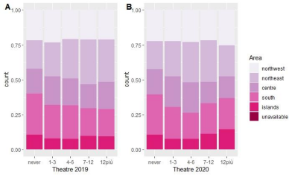

Can be conducted the same analysis on the turnout at the cinema: comparing the purple graphs A and B, it is clear that the affluence has remained mainly unchanged between geographical districts and the two years. In 2019, those who attend the cinema more are people of the centre, while those who attend it less are the ones from the South. In 2020, instead, residents of the northwest and northeast mostly go to the cinema, while inhabitants of the south remain those who go less to the cinema.

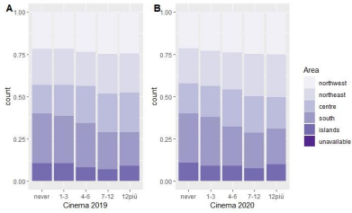

It is also interesting to observe the distribution of museum visits among geographical areas between 2019 and 2020. Even in that case, the situation is mostly unchanged in the considered period. There is only a slight variation noticeable through blue graphs: museum visits from inhabitants of the northwest among the most frequent museum visitors increase. It implies that the inhabitants of the northwest visit museums more than twelve times a year in both periods. On the other hand,

individuals that go less to museums are southerners once again. In addition, it is apparent that the tendency to attend museums at least once a year is more widespread in the centre-north, including the northwest, northeast, and centre, compared to the south.

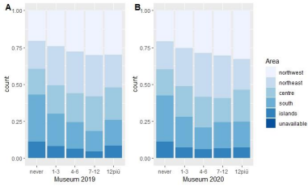

As regards classical music concerts, a particular situation verifies. In 2019 and 2020, people who have attended at least twelve times in the 12 months before classical concerts reside in the centre north. However, the difference in participation, between the centre-Nord and the regions of the south, including the islands, is visibly reduced over the period considered. This is even more evident considering those who attend classical music concerts between seven and twelve times a year: while in 2019, most of the people who attended classical music concerts with this frequency were from the centre-nord, in particular from the northwest, in 2020 the number of residents in the centre-nord, attending the theatre, substantially declined. This trend may be due to the spread of coronavirus: this disease has probably mainly affected the north.

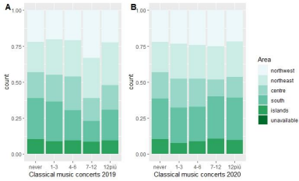

As for concerts other than classical music, residents of centre-north show a slightly higher aptitude to attend concerts than those in the south in general terms. More in detail, the people who went to

the concerts at least twelve times a year between 2019 and 2020 are from the south and the northeast. However, while in 2019, people who participated more in music concerts are mainly southerners, in 2020, they are mainly inhabitants of the northeast. It is clear a slight reduction in the proportion of southerners and a slight increase in northeast inhabitants attending concerts more often in the considered timeframe.

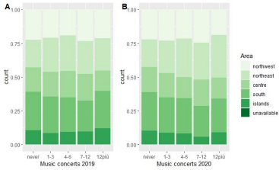

Focusing on monuments and archaeological sites at the territorial level, it is clear that residents of the centre-north have a greater propensity to visit these places than southerners. In particular, the highest levels of abstinence of archaeological sites are recorded in the south, while the inhabitants of the northwest stand out among those who visit these places at least once a year in the considered time frame. A fairly pronounced variation in the distribution of visits to monuments between geographical areas and between 2019 and 2020 concerns those with a frequency of participation between seven and twelve times a year. In fact, the interest of the northeast inhabitants increases quite substantially.

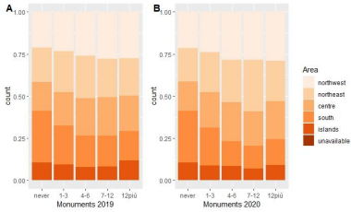

Until now, we have seen that in most cases, the inhabitants of the north tend to frequent entertainment activities outside the home more often than the inhabitants of the south. This trend is

confirmed by Istat 2019 and 2020 reports which also state that there is greater participation in cultural services in metropolitan areas while it is residual in small municipalities. This further supports the results obtained as metropolitan areas are concentrated in the north, while small towns characterise most of the south. This result may also be due to the different distribution of the offer of entertainment activities outside the home on a territorial level. For example, as reported by Istat in the report published last year and related to the year 2020, most museums, archaeological sites, monuments, and monumental complexes are located in the regions of the north (46.2%), and only 28.9% and the 24.9% are located respectively in the centre and the south.

The tendency to attend out-of-home entertainment varies not only by geographical area, but also by age, gender, and education. For instance, we can consider the cinema, as it has the lowest abstinence level, and see how these factors affect the frequency with which individuals attend it. Let’s consider first the relation between the frequency, age, and gender among those who go to the cinema with an average frequency, and so, between four and six times a year in 2019 and 2020. The graph below shows that in 2019 especially young people up to 24 years old visited the cinema; more in detail, children between the ages of 20 and 24 and children between 6 and 10 go to the cinema more frequently. On the contrary, people between 65 and 70 and especially over 75 years of age benefit less from this type of cultural service as they use it less. Therefore, the tendency to go to the cinema comes down to increasing age. As for gender, the trend of going to the cinema, in 2019, is almost equally distributed between men and women. Among young people up to 24, girls go to the cinema slightly more than their peers: especially among young people between 15 and 17 years old, where the difference between the frequency of women and men is more marked. Women also prevail among men between 54 and 60 years of age. In the remaining age groups, men attend cinema slightly more than women.

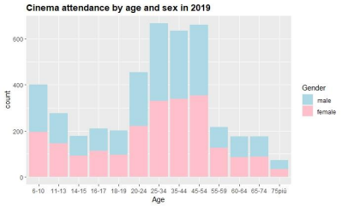

By conducting the same analysis in 2020, similar results are achieved: as shown by the graph below, the habit of going to the cinema between four and six times and therefore with an average frequency, in 2020, is more widespread among young people. Those who attend this place the most are young people between 20 and 24 years and children between six and ten years. They follow in descending order of frequency the men between 65 and 74 years and the elderly over 75 years. So, even in this case, the tendency to go to the cinema is reduced with increasing age. As for gender, the number of women who attend the cinema differs slightly from that of men in most cases. Among the young up to 24 years, there are more female frequenters, especially in the range from 16 to 17 years. The number of female frequenters is slightly higher also in the 45-54, 55-59, and 65-74 age groups. On the other hand, men prevail between 18 and 19 years and between 25 and 34.

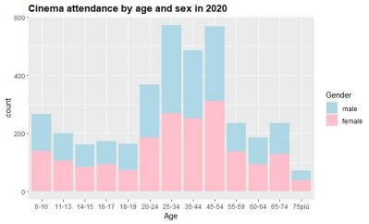

Let us now examine the relationship between the type of cultural service and the level of education of those who use it. Let’s take cinema, for example, because it is the type of entertainment characterised by the lowest level of abstinence. The chart below shows cinema participation relative to the educational level in 2019 among those who go to the cinema between 7 and 12 times a year. People who visit the cinema with this attendance have mostly a high school diploma, it is less the number of people with a degree or doctorate; even fewer is the number of students with a diploma in Middle School. Overall, it seems that the tendency to attend the cinema increases with the level of education up to the high school diploma, and then this trend is reversed. The trend reversal may occur because not everyone continues their studies after graduating from high school. This further supports previous results, according to which young people up to 24 years go to the cinema more often than older people.

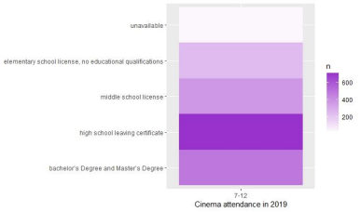

The situation is similar in 2020, where the tendency to attend the cinema still increases with the level of education up to the high school diploma and then decreases slightly for higher education levels. In that case, contrary to 2019, the number of people with a degree or doctorate who visit the cinema, with attendance slightly higher than the average, is moderately higher than the one of those

with a high school license. In 2019, the difference between the two numbers was more accentuated. In addition, the nuances of the 2020 graph are lighter, indicating a reduction in the number of cinema-goers between 7 and 12 times a year. This variation is also noticeable through the numbers corresponding to each level of study, which is lower than the ones of 2019. The decrease is probably due to the emergency measures that the government introduced in 2020 to counter the spread of covid-19. Therefore, the greater transparency of nuances in 2020 compared to 2019 is probably also found in other types of entertainment outside the home.

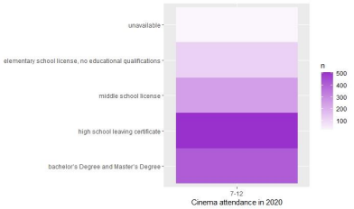

The same reasoning can also be applied to the museum. Observing how many people go to the museum between seven and twelve times a year depending on the level of education, it is clear that the number of people attending museums still tends to increase with the level of education. This trend is confirmed in 2019 and 2020, as shown by the blue charts below.

In particular, in 2019, the people attending the museum between seven and twelve times are mainly graduates and doctorates; no more people with a high school diploma which corresponds to a smaller number of visitors.

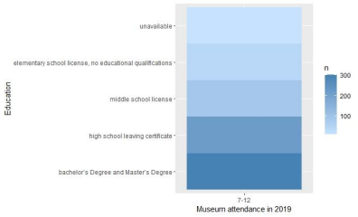

In 2020, the peak is still among graduates and doctorates, although lower than the previous year. This is might due to the introduction of emergency measures. In addition, there is also a reduction in cinema-goers with the diploma of eighth grade. This change probably also stems from the emergency measures ordered by the government, including the temporary closure of schools.

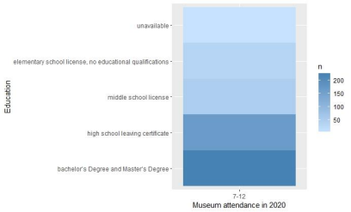

The analysis showed that the tendency to attend out-of-home entertainment decreased between 2019 and 2020, maybe because of emergency measures issued in March 2020 to combat the spread of the coronavirus. By analysing the influx of these cultural services on a territorial level, it is found that the inhabitants of the north are the most culturally active. This is probably due to the distribution of these services between geographical areas. As reported in the report of Istat, the use of these services is greater where the infrastructure offer is higher and so in metropolitan areas that characterise more the north. - -- Furthermore, it is observed how gender and age affect participation in these activities. Focusing on the cinema and the people who go there between 4 and 6 times a year, it is clear that participation decreases with age. Moreover, in 2019 and 2020, among young people up to 24 years old, cinema-goers are especially women. In the other age groups, men seem to prevail slightly. In the end, the difference between the number of male and female frequenters is subtle. Focusing instead on cinema attendance by education level, it is found that those who visited the cinema between 7 and 12 times between 2019 and 2020 are mostly people with high school leaving certificates. In general, as the level of education increases, the frequency with which people attend the cinema increases. 2020 are mostly people with high school leaving certificates. In general, as the level of education increases, the frequency with which people attend the cinema increases. The same result is reached by analysing the attendance at the museum with the difference that, in this case, most people are graduates or have doctorates instead of having high school leaving certificates.

**References**

* Ministero della Cultura. (2020, March 8). *COVID-19: Nuove disposizioni urgenti – Chiusi in tutta Italia cinema, teatri, musei, parchi archeologici, archivi e biblioteche*. Retrieved from  
  <https://www.beniculturali.it/comunicato/covid-19-nuove-disposizioni-urgenti-chiusi-in-tutta-italia-cinema-teatri-musei-parchi-archeologici-archivi-e-bibliotechecovid-19-new-urgent-provisions-closed-all-over-italy-cinemas-theatre-museums-archeological-sites-archives-1>
* ISTAT. (2020). *Aspetti della vita quotidiana - Anno 2019* (Capitolo C10). Retrieved from <https://www.istat.it/it/files/2020/12/C10.pdf>
* ISTAT. (2021). *Aspetti della vita quotidiana - Anno 2020* (Capitolo C10). Retrieved from  
  <https://www.istat.it/storage/ASI/2021/capitoli/C10.pdf>
* ISTAT. (2022). *Musei e istituzioni similari in Italia*. Retrieved from  
  <https://www.istat.it/it/files/2022/02/REPORT_MUSEI-E-ISTITUZIONI-SIMILARI-IN-ITALIA.pdf>

ISABELLA CAPPIELLO